Access 2000 Based
Randomization Software
Version 1.10

User Manual

Software Created by Peter Charpentier
December 2003

Original Urn Randomization User Manual
written by Tami Frankforter
February 2004

Note: This manual has been modified from the original Urn Randomization User Manual (Frankforter, 2004) to be specific to the CJ-DATS Steppin’ Out study protocol.

I. INSTALLATION……………………………………………….………….3.. 3

II. STARTING THE PROGRAM…………..……………………….………3-4

III. RANDOMIZATION OF PARTICIPANTS…….……..……………….4-10

IV. REPORTS & OTHER MENU FEATURES……………………...…...10-11

V. BACK-UP……………………………………………………………….…11

Installation
The Urn Randomization program is distributed in a zipped file containing 3 files. Grand.mdb and grdata.mdb are the primary files for running the Urn program. These files require MS Access 2000 be loaded on the workstation hard drive in order to function properly. The remaining file (Steppin’ Out Urn Randomization User Manual.doc) is a copy of this document in MS Word 2000 format.

To install this program, copy the Grand.mdb and grdata.mdb files to the workstation. Using the mouse, locate and highlight (if not already highlighted) the Grand.mdb program by left clicking on the file once. Note that the file is already highlighted if a blue box surrounds the file. Right-click on the highlighted Grand.mdb program and select the “” option from the pop-up menu. From the next pop-up menu, select the “” option. A Grand.mdb shortcut icon will appear on the workstation desktop. The user can always double-click on this shortcut icon to open the Urn Randomization program.

II.Starting the Program
The Urn Randomization program opens with a sign on screen. You can enter any name and click on the ‘Proceed’ button. This is not a security measure. This program has no security measures built into it and the data stored in the database is accessible to anyone who has access to the workstation that runs the program.

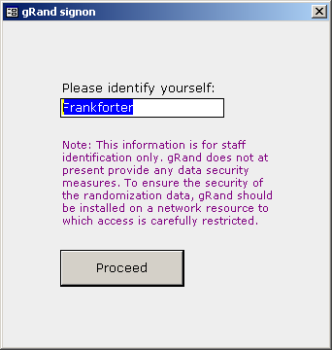

Figure 1: Sign On Window
The next screen is the Options and Report Menu window displayed in Figure 2. Each option is described in the following sections.

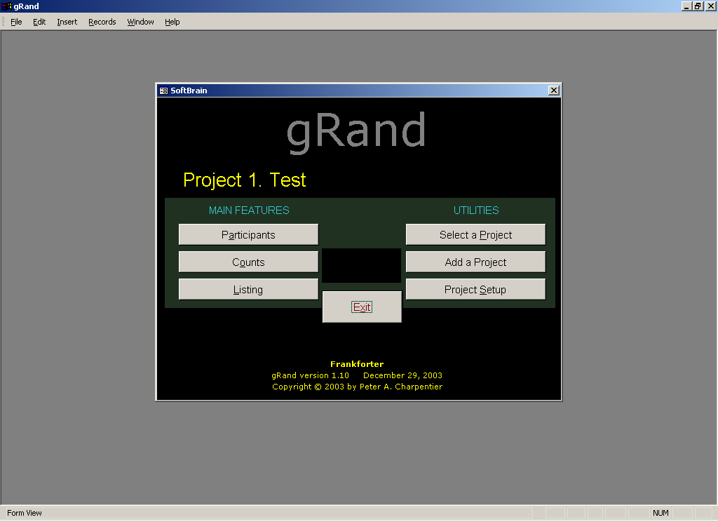
Figure 2: Options and Reports Menu window.

III. Randomization of Participants

Selecting the Steppin’ Out Urn Randomization
Click on the ‘Select Project' button in the Options and Report Menu window to open the Project Selection window in Figure 3.

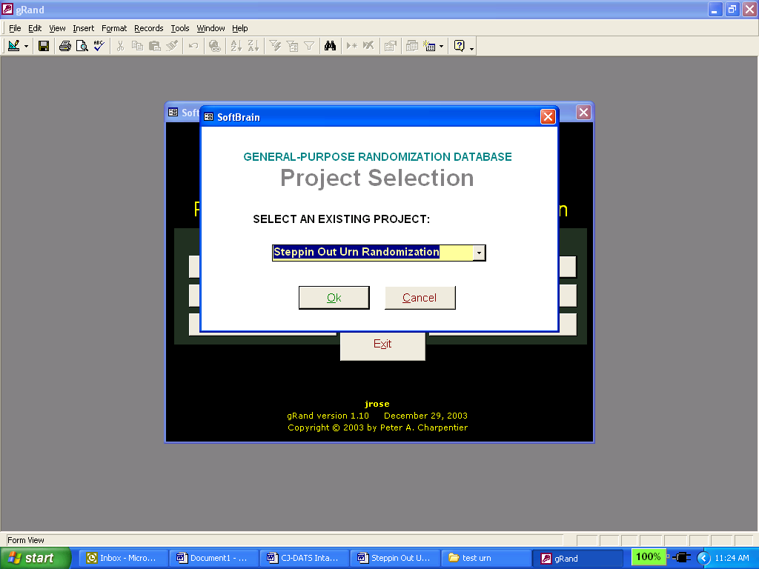

Figure 3. Project Selection Window

Once the Project Selection window opens, click on the down arrow button to display and select the Steppin Out Urn Randomization project name. Click the ’OK’ button and the focus returns to the Options and Reports Menu window (Figure 2). You will notice the Window now has the project name that was selected at the top.

Participants

Adding Participants
The Participant Data (outer) window in Figure 4 appears when the ‘Participant’ button is pressed for the first time. At this point no subjects have been entered into the randomization database.

To add the first participant, click on the ‘New…’ button and enter the participant identification code (ID) and click the ‘OK’ button. The ID is a 6 digit number: the first two digits indicate the Research Center ID number and the last 4 digits indicate the sequential Client ID number, following the standardized CJ-DATS format. Click on the ‘Randomization Data’ button at the top of the Participant Data window to open the Factors window (Figure 7).

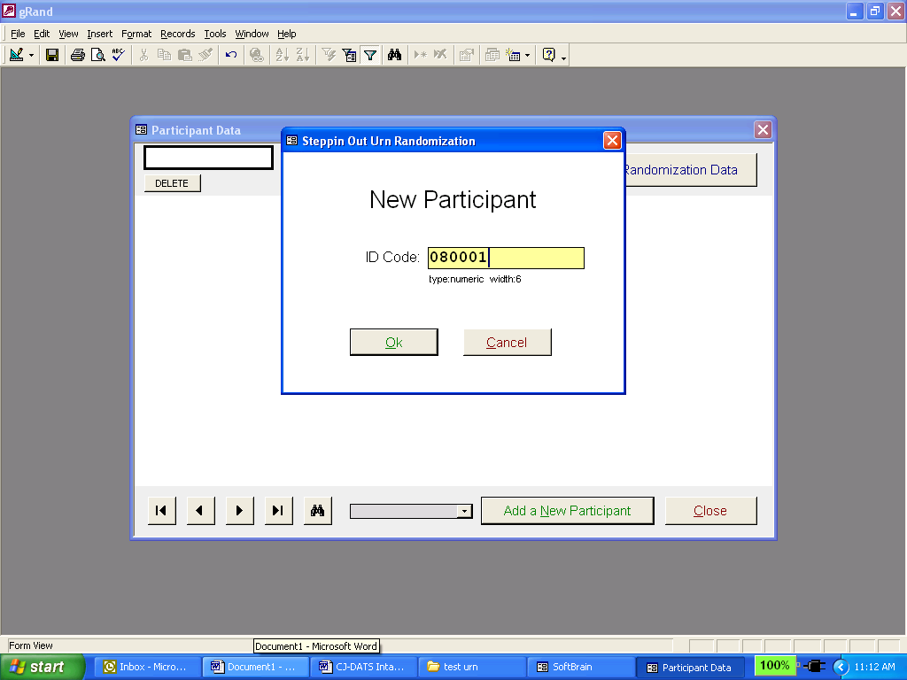
Figure 6: The Participant Data window with the New Participant window opened after the 'New' button is clicked with an ID number entered. In this example, the first 2 digits “08”indicate the Research Center ID (Rhode Island), and the last 4 digits are the sequential Client ID number (in this case, 0001 to represent the first client).

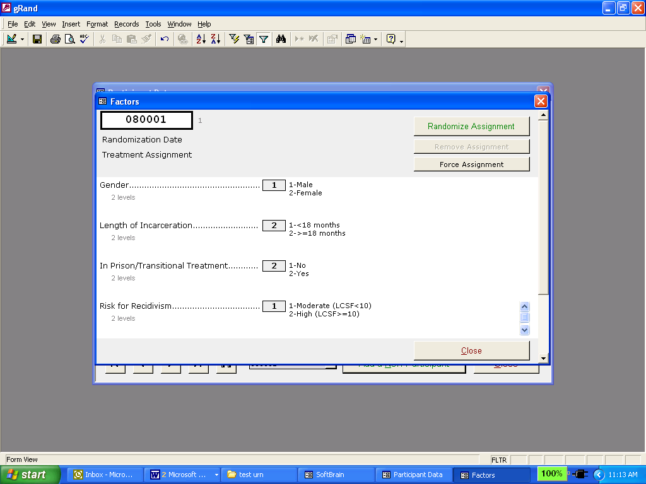
Figure 7: The Factors window accepts participants’ screening data to randomize the participant.

In order to enter the data, you must place the cursor in the first factor entry box by highlighting the entire area of the box. You then enter the first value and hit the ‘Enter’ key. A word of caution, each factor has a default field length of 2, so be careful when entering single digit values. Once you enter the required Randomization Data, click the ‘Randomize Assignment’ button. The program will prompt you to make sure you wish to randomize the participant. Click the ‘OK’ button. The program will randomize the participant and display the Treatment Assignment and Randomization Date in the upper left section of the Factors window (see Figure 8). Note the ‘Randomize Assignment’ button must be clicked for the participant to be randomized. Next click the ‘Close’ button in the Factors window after the randomization assignment group and date have been transferred to the appropriate reporting forms.

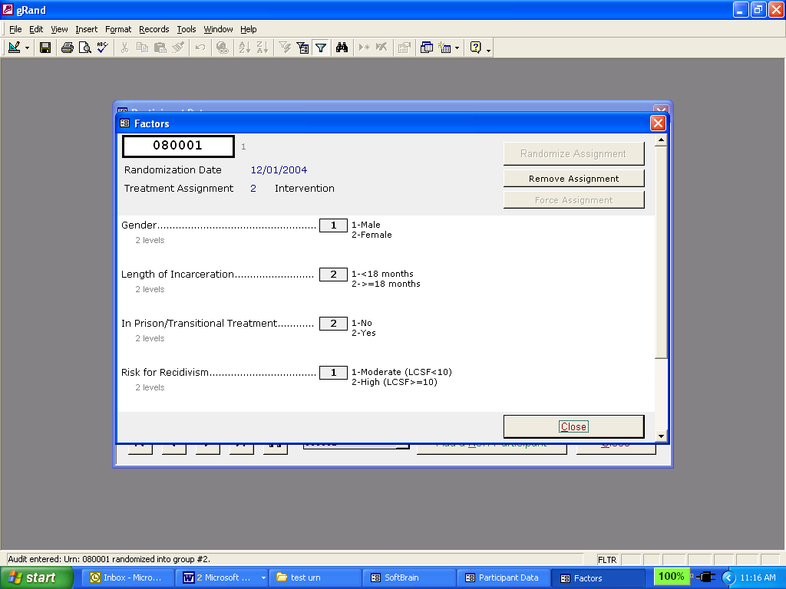

Figure 8: The Factors window displaying the treatment assignment information following entry of a client’s values on the randomization factor and after clicking the Randomize Assignment button.

Additional participants are entered in the Urn Randomization program by repeating the procedures outlined above. When multiple participants have been entered in the database the navigation buttons located at the bottom of the Participant Data window (Figure 7) will help navigate through the records.

Deleting Participants

To delete an ID that has not been randomized, click the ’Delete Participant’ button located in the upper right corner of the Participant Data window. Click the ‘OK’ button in the confirmation window to confirm the deletion. If a window opens with the message “You must de-randomize before deleting!”, then click the ’OK' button and de-randomize the client. If the participant has already been randomized, you must consult with the Research Center PI prior to de-randomizing, and all instances of de-randomization should be carefully documented and reported to the Lead Center in the monthly randomization progress reports.

De-randomizing Participants

To de-randomize a participant, find the participant’s record and click on the ‘Randomization Data’ button. Then click on the ‘Remove Assignment’ button. The program will prompt you to make sure that you wish to remove the participant. Click on the ‘OK’ button. Then Click on the ‘Close’ button to return to the participant data window.

Forcing Randomization Assignment for a Participant

The program allows you to assign a treatment group to a client without using the urn process. This is not a recommended procedure but can be used when a randomization problem requires it. The Lead Center PI MUST be consulted before a decision is made to force randomization. The Lead Center PI will discuss the problem with the Research Center PI, and will make the decision as to whether or not randomization should be forced. All randomization problems and associated decisions should be carefully documented and reported to the Lead Center in the monthly randomization progress reports.

To enter the participant’s randomization code, find the participant’s record and click on the ‘Randomization Data’ button. Note the randomization data must be entered even though you are not using the randomization process. Then click on the ‘Force Assignment’ button. The program will prompt you to make sure that you wish to force the assignment. Click on the ‘OK’ button. The window will pop up asking for you to enter the treatment assignment number (figure 9). Enter the treatment value and click the ‘OK’ button. Then Click on the ‘Close’ button to return to the participant data window.

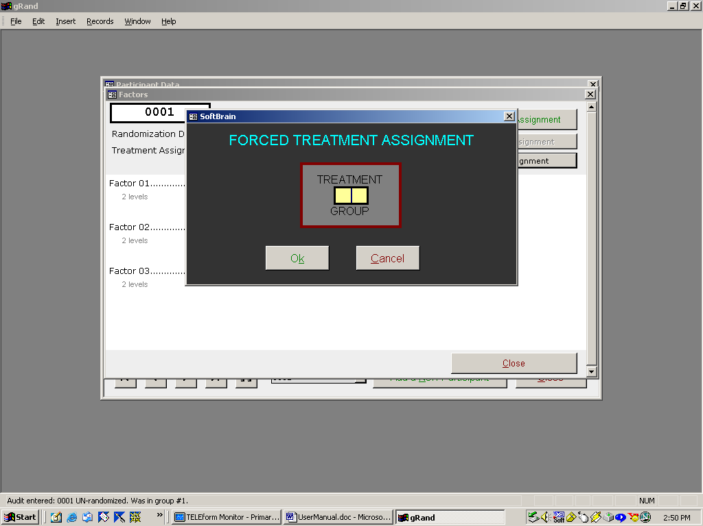

Figure 9. The Screen for entering in a forced treatment assignment

Reports & Other Menu Features

a. Counts Reports
For the selected protocol project, the ‘Counts’ button opens two reports:
      - Counts by Factor Level Report: This report displays the counts in each level for each of the factors
      - Counts by Project for Treatment Group: This report displays the count of participants in each treatment group.

Both Count reports should generated once a month, and submitted to the Lead Center for review.

Listing Reports
The Listing Report displays the randomization data for each participant. The output for each ID includes the Treatment Group.

A Listing Report should be generated quarterly, and submitted to the Lead Center for review.

Exit Option Button
Click the ‘Exit’ button to exit the Urn Randomization program.

Back-up
The Urn Randomization program should be backed-up on a daily basis. Both the Grand.mdb and grdata.mdb files should be copied to an alternate drive or other type of media such as a zip disk or CD.

